**Practical No. 01**

## Write an Application to Create Calculator

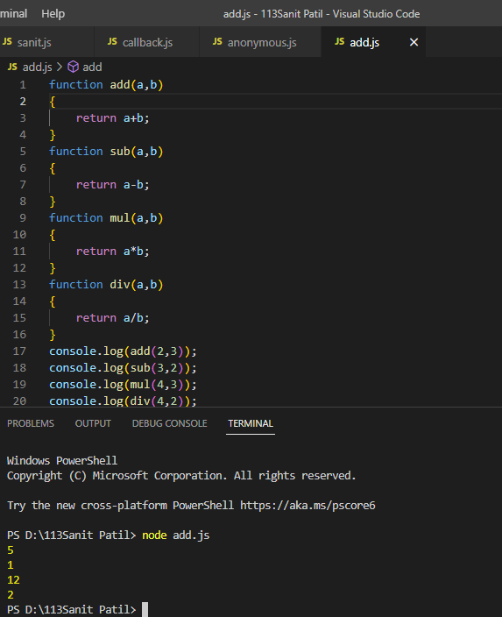

**Practical No. 02**

# Write an Application to Create Callback Function

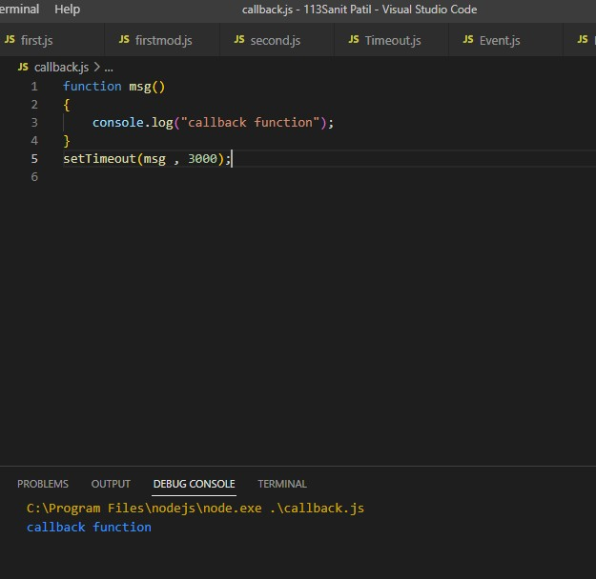

**Practical No. 03**

## Write an Application to Create Arrow Callback Function

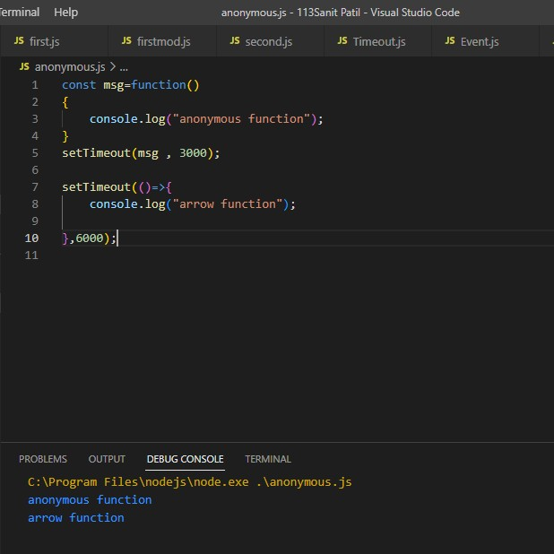

**Practical No. 04**

* Write an Application to Create Even Odd Function

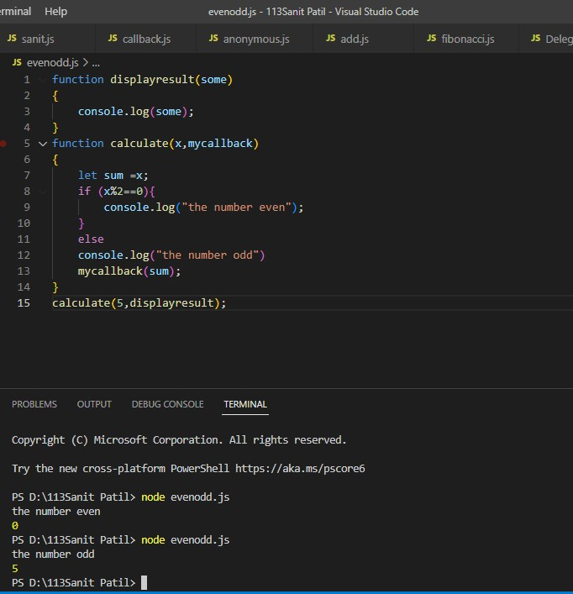

**Practical No. 05**

## Write an Application to Create Fibonacci Function

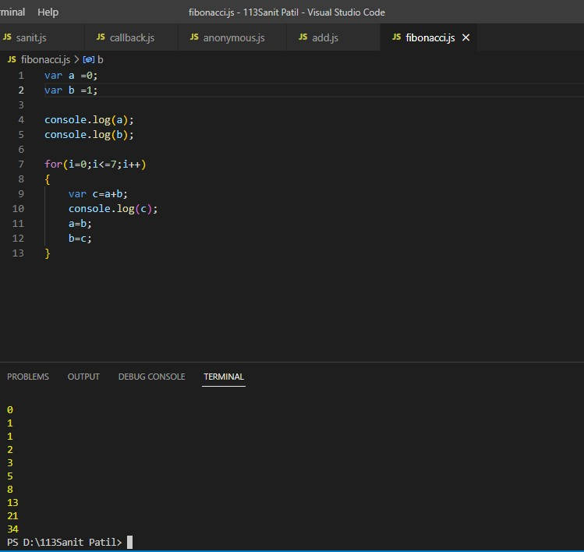

**Practical No. 06**

* **Write an Application to Create Demonstrate Module**

##### 1. ADD

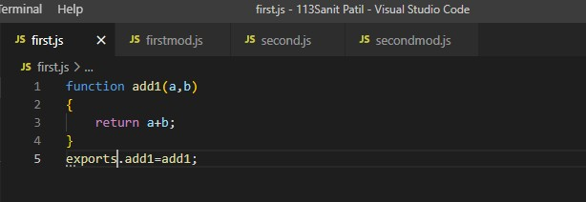

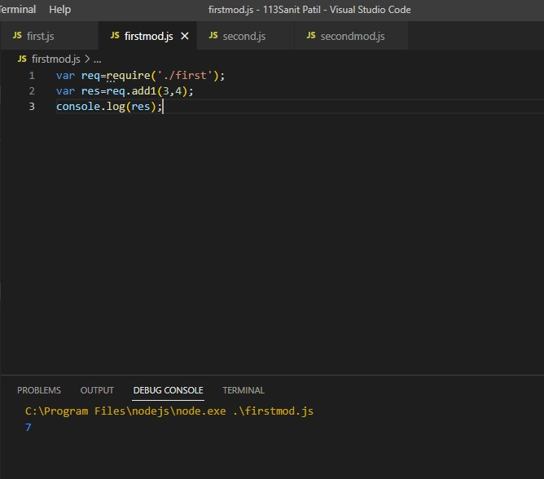

**Practical No. 07**

### Write an Application to Find Perimeter of Circle,Rectangle & Square using Modules

1. Perimeter of Circle
2. Perimeter of Rectangle
3. Perimeter of Square

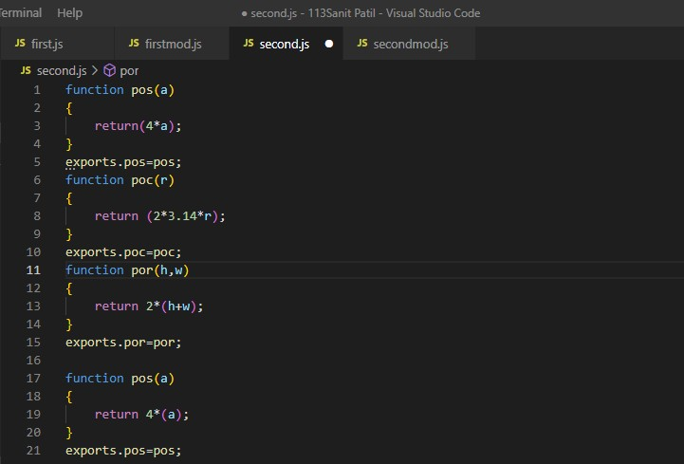

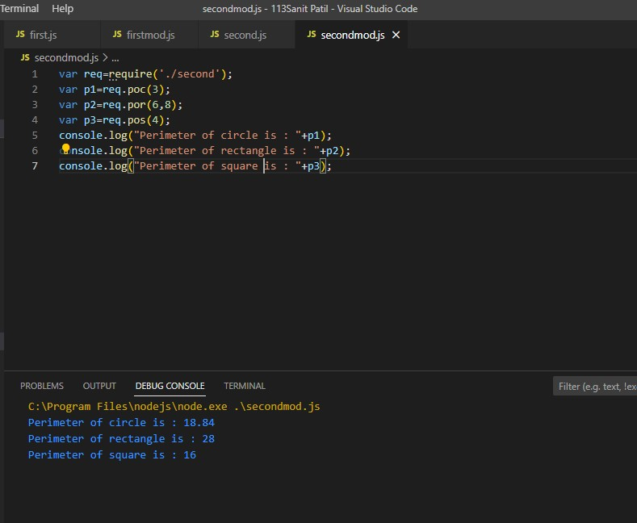

**Practical No. 08**

# Write an Application to Display a message after 5 & 6 respectively.

##### 1. Timeout

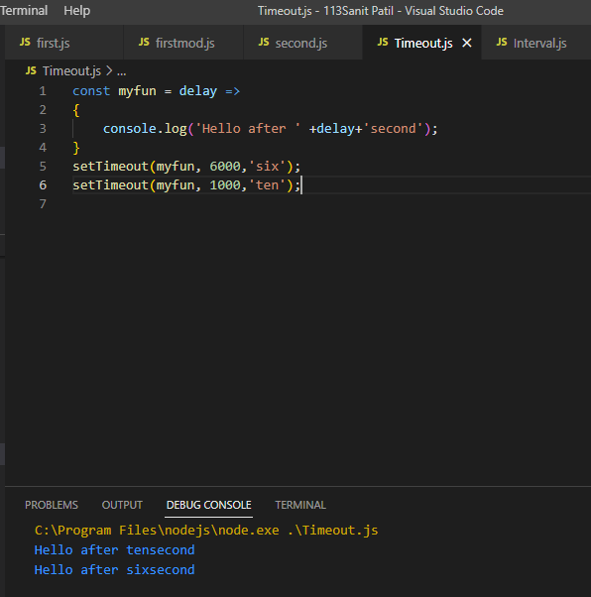

**Practical No. 09**

# Write an Application to Demonstrate Set Interval Function

1. Interval

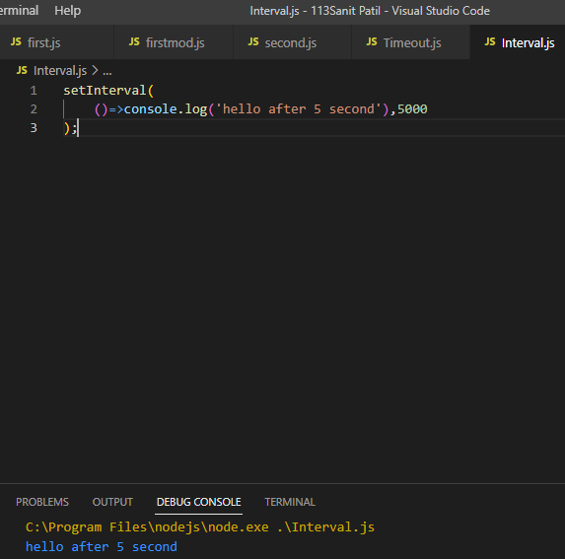

**Practical No. 10**

# Write an Application to Demonstrate Clear Timeout Function

## Timeid

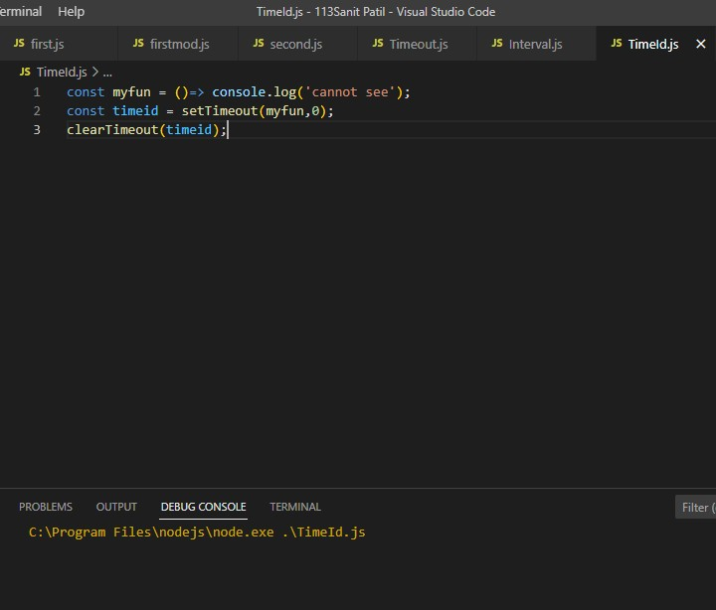

**Practical No. 11**

##### Write an Application to Demonstrate EventEmitter

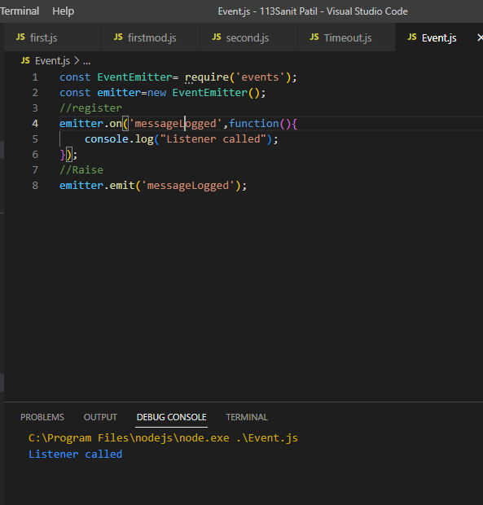

**Practical No. 12**

* Write an Application to Demonstrate Event type

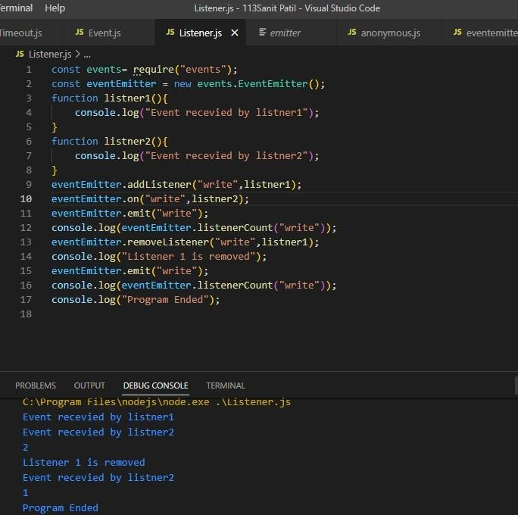

**Practical No. 13**

##### Event Emitter Pattern

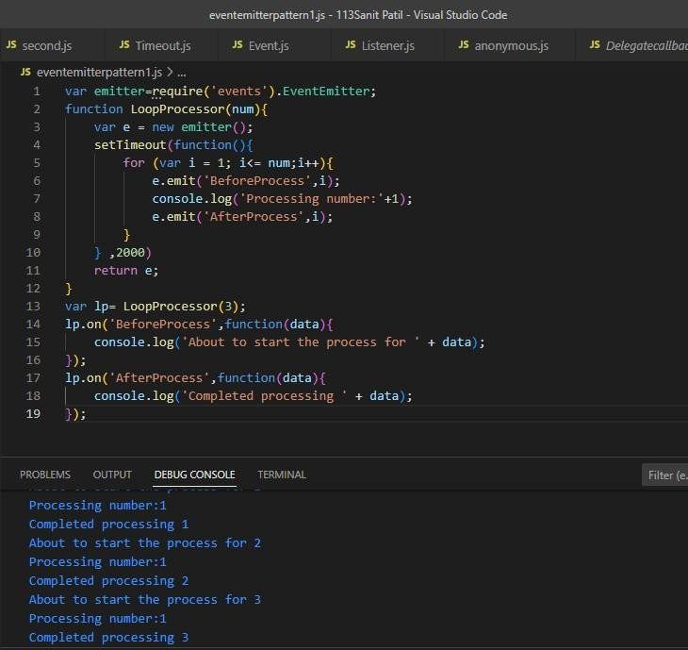

**Practical No. 14**

* Write an Application to Extend Emitter Pattern

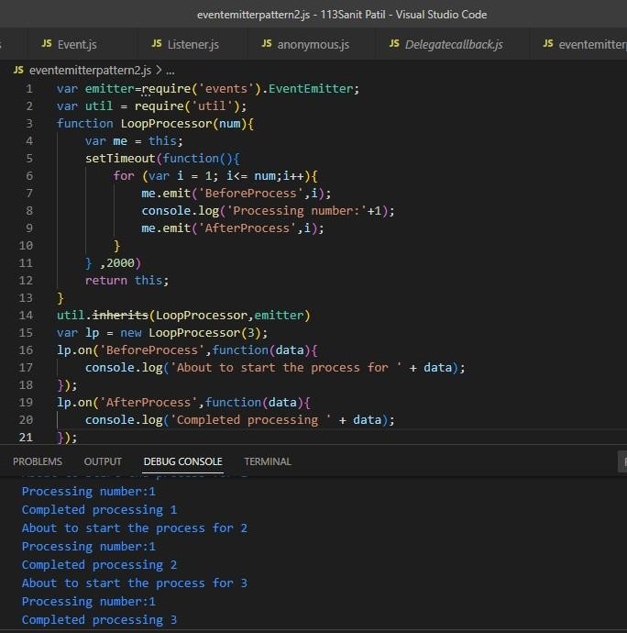

**Practical No. 15**

##### Write an Application to Create http server & display message.

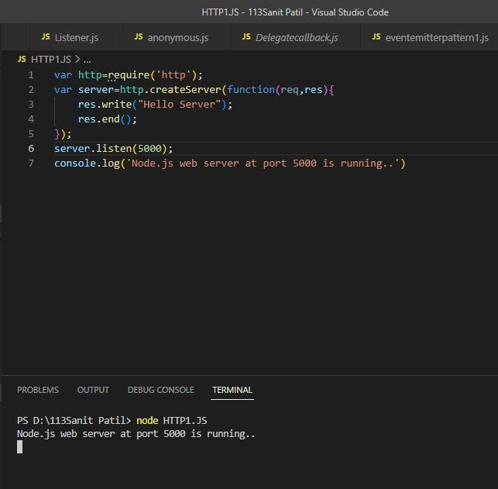

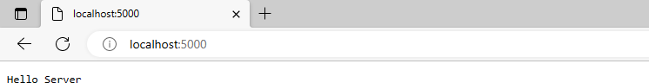

**Practical No: 16**

* Write an application to create Home,Admin & Student Pages using http server.

var http=require('http');

var server = http.createServer(function(req,res)

{

if(req.url=='/')

{

res.writeHead(200,{'Content-Type':'text/html'}); res.write('<html><body><style>body{background-

color:gray}</style><p>This Is Page.</p></body></html>'); res.end();

}

else if(req.url=='/home')

{

res.writeHead(200,{'Content-Type':'text/html'}); res.write('<html><body><p><style>body{background- color:lightskyblue}</style>This Is Home Page.</p></body></html>');

res.end();

}

else if(req.url=='/student')

{

res.writeHead(200,{'Content-Type':'text/html'}); res.write('<html><body><p><style>body{background-

color:papayawhip}</style>This Is Student Page.</p></body></html>'); res.end();

}

else if(req.url=='/admin')

{

res.writeHead(200,{'Content-Type':'text/html'}); res.write('<html><body><p><style>body{background- color:lightyellow}</style>This Is Admin Page.</p></body></html>');

res.end();

}

else

res.end('Invalid Request!');

});

server.listen(5000);

console.log('Node.js Web server at port 5000 is running..')

**Output:**

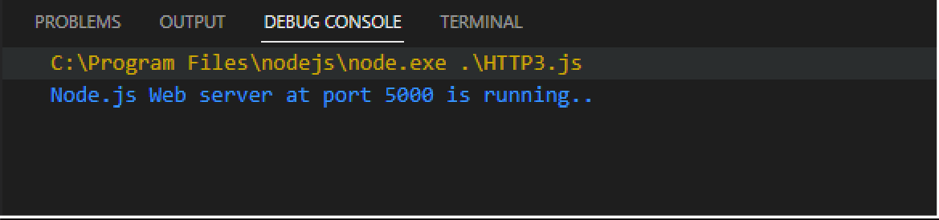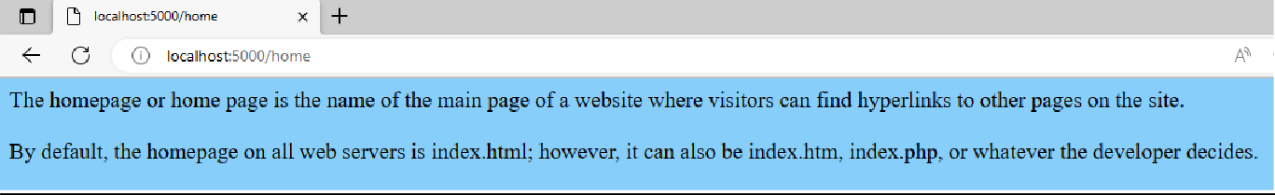

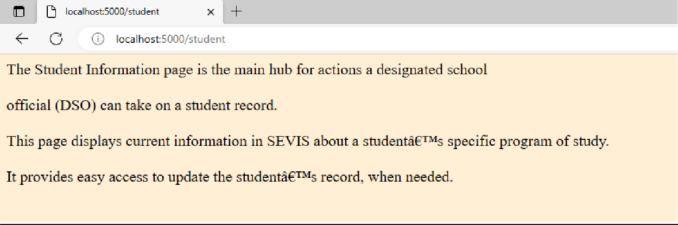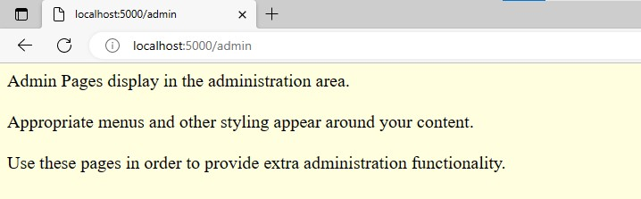

**Practical No. 17**

##### Write an Application to Display the details of the current file.

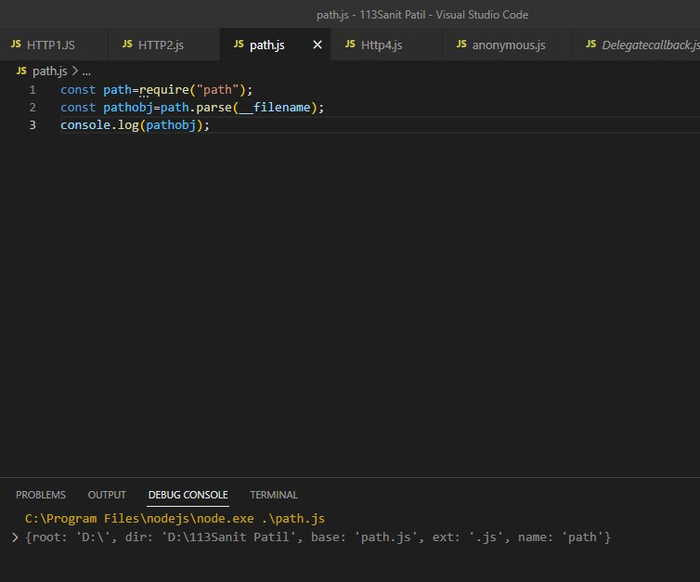

**Practical No. 18**

##### Write an Application to Read a File.

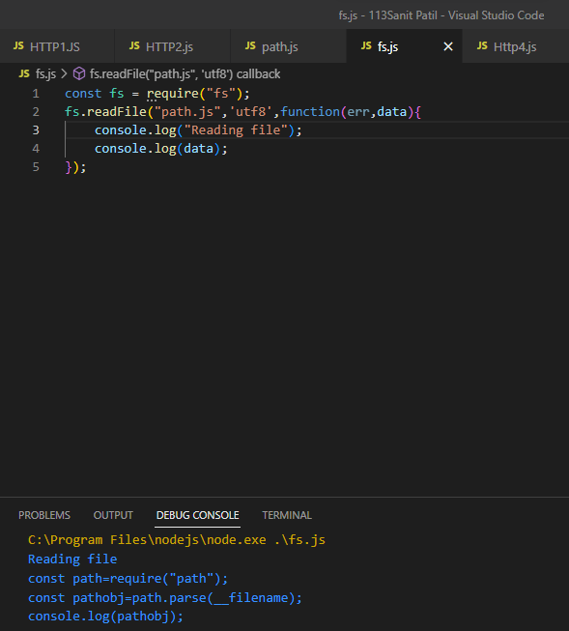

**Practical No. 19**

* Write an Application to Write into the File.

const fs = require("fs"); fs.writeFile("path.js",'console.log("Hello")',function(err,data){

console.log("writing file"); console.log(data);

});

**Output:**

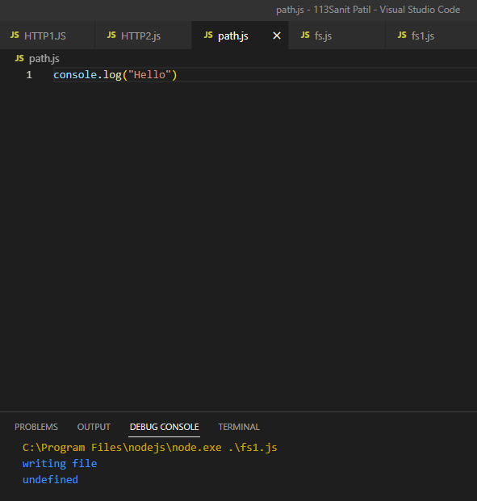

**Practical No. 20**

* Create an Application to Add Data into a Existing File
* const fs = require("fs");
* fs.appendFile("hello.txt",'console.log("Hello")',function(err,data){
* console.log("append");
* console.log(data);
* });

#### Output:

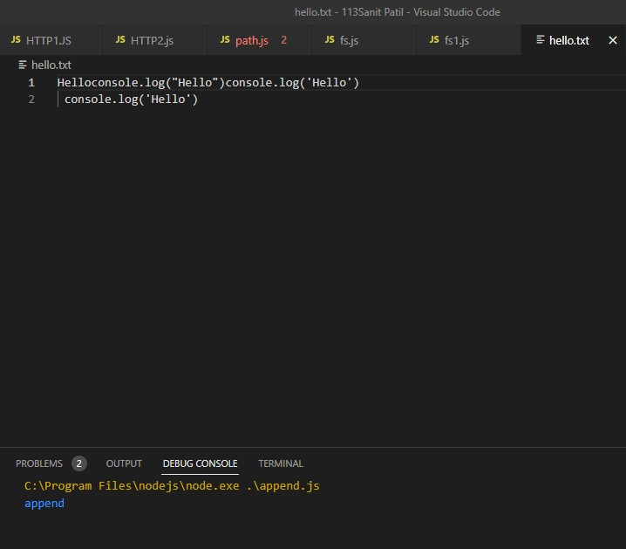

**Practical No. 21**

* Create an Application to Rename the File.
* const fs = require("fs");
* fs.rename("hello.txt","Sanit.txt",function(err,data){
* console.log("rename File");
* });

#### Output:

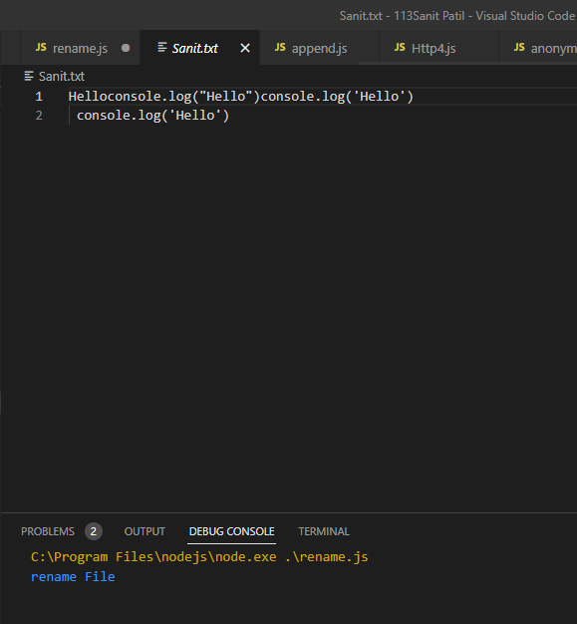

**Practical No. 22**

* Create an Application to Delete the File.
* const fs = require("fs");
* fs.unlink("Sanit.txt",function(err,data){
* console.log("delete File");
* });

#### Output:

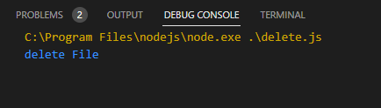



**Practical No. 23**

#### Create an Application to Create DATABASE using Mysql

var mysql =require('mysql');

var con =mysql.createConnection({ host:'localhost', user:'root',

password:""

});

con.connect(function(err){ if(err)throw err; console.log("Connected");

con.query("CREATE DATABASE ROLLNo_113",function(err,result){ if(err)throw err;

console.log("database created");

});

});

**Output:**

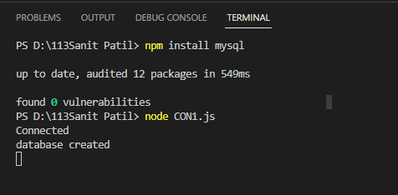

**Practical No. 24**

#### Create an Application to Create faculty table with column as faculty_name,faculty_design,faculty_mobile no.& faculty_salary

var mysql =require('mysql');

var con =mysql.createConnection({ host:'localhost', user:'root',

database: "ROLLNo_113"

});

con.connect(function(err){ if(err)throw err; console.log("Connected");

con.query("create table faculty(fac_name varchar(10),fac_designation varchar(10),fac_mobile int,fac_subj varchar(20),fac_salary int);",function(err,result){

if(err)throw err; console.log("table created");

});

});

**Output:**

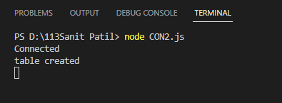

**Practical No. 25**

#### Create an Application to Insert Rows into Faculty Table using Mysql

var mysql =require('mysql');

var con =mysql.createConnection({ host:'localhost', user:'root',

database: "ROLLNo_113"

});

con.connect(function(err){ if(err)throw err; console.log("Connected");

con.query("insert into Faculty values('Rahul W.','Teacher',123456789,'JAVA',150000);",function(err,result){

if(err)throw err; console.log("Data Inserted");

});

});

**Output:**

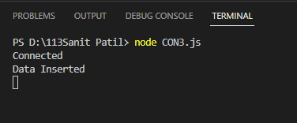

**Practical No. 26**

#### Create an Application to Display Record

var mysql =require('mysql');

var con =mysql.createConnection({ host:'localhost', user:'root',

database: "ROLLNo_113"

});

con.connect(function(err){ if(err)throw err; console.log("Connected");

con.query("select * from faculty;",function(err,result){ if(err)throw err;

console.log("Data Displayed");

});

});

**Output:**

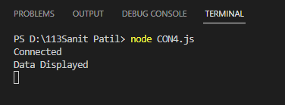

**Practical No. 27**

#### Create an Application to Update a Row

var mysql =require('mysql');

var con =mysql.createConnection({ host:'localhost', user:'root',

database: "ROLLNo_113"

});

con.connect(function(err){ if(err)throw err; console.log("Connected");

con.query("update faculty set fac_salary=200000, fac_designation='HOD' where fac_subj='JAVA';",function(err,result){

if(err)throw err; console.log("Data Updated");

});

});

**Output:**

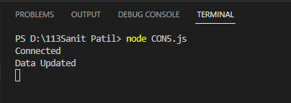

**Practical No. 28**

#### Create an Application to add a column faculty address to the faculty table

var mysql =require('mysql');

var con =mysql.createConnection({ host:'localhost', user:'root',

database: "ROLLNo_113"

});

con.connect(function(err){ if(err)throw err; console.log("Connected");

con.query("alter table faculty ADD fac_email varchar(20);",function(err,result){

if(err)throw err; console.log("Table Altered");

});

});

**Output:**

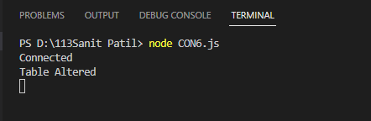

**Practical No. 29**

#### Create an Application to Delete Record in faculty table

var mysql =require('mysql');

var con =mysql.createConnection({ host:'localhost', user:'root',

database: "ROLLNo_113"

});

con.connect(function(err){ if(err)throw err; console.log("Connected");

con.query("delete from faculty where fac_subj='JAVA';",function(err,result){ if(err)throw err;

console.log("Table Deleted");

});

});

**Output:**

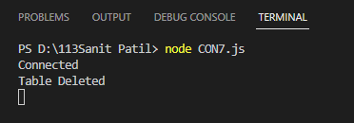

**Practical No. 30**

#### Create an Application to Demonstrate Array using Angular JS.

<!DOCTYPE html>

<html lang="en">

<head>

<script src="angular.min.js"></script>

<meta charset="UTF-8">

<meta http-equiv="X-UA-Compatible" content="IE=edge">

<meta name="viewport" content="width=device-width, initial- scale=1.0">

<title>Document</title>

</head>

<body>

<body ng-app="">

<body ng-init="arr1=[0,10,20,100,20]">

<p>First element{{arr1[0]}}</p>

<p>Third element{{arr1[2]}}</p>

<p>Fourth element{{arr1[3]}}</p>

</div>

</body>

</html>

#### Output:

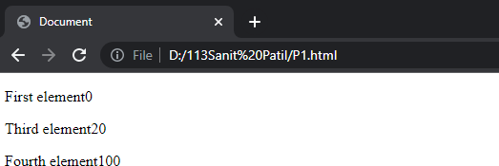

**Practical No. 31**

#### Create an Application to to create an array & display the element in order list

<!DOCTYPE html>

<html lang="en">

<head>

<script src="angular.min.js"></script>

<meta charset="UTF-8">

<meta http-equiv="X-UA-Compatible" content="IE=edge">

<meta name="viewport" content="width=device- width, initial-scale=1.0">

<title>Document</title>

</head>

<body>

<div ng-app="" ng- init="arr1=[{Fruit:'Apple',color:'Red'},{Fruit:'O range',color:'Orange'}]">

<ol>

<li ng-repeat="i in arr1">

{{i.Fruit+','+i.color}}

</li>

</ol> Addition={{2+5+10}}

</div> Substraction={{100-90}}

</body>

</html>

#### Output:

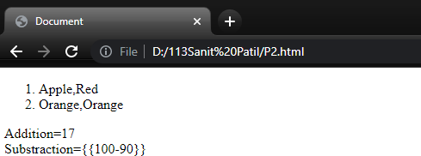

**Practical No. 32**

#### Create an Application to Angular to display marksheet of a student

<!DOCTYPE html>

<html lang="en">

<head>

<script src="angular.min.js"></script>

<meta charset="UTF-8">

<meta http-equiv="X-UA-Compatible" content="IE=edge">

<meta name="viewport" content="width=device-width, initial- scale=1.0">

<title>Document</title>

</head>

<body style="background-color: cadetblue;">

<div ng-app ng-init= "arr1=[{subject:'Web Technology', marks: '50'},{subject : 'Advance Java', marks : '70'},{subject:'Data Structure', marks: '77'},{subject : 'SPM', marks : '68'}]" style="width: 500px; margin: 0 auto; font-size: 30px; text-align: center;">

<p>NCRD'S STERLING INSTITUTE OF MANAGEMENT STUDIES</p>

<p>STUDENT NAME: Sanit Patil </p>

<p>ROLL NO. :113 </p>

<ol>

<li ng-repeat = "i in arr1">

{{i.subject +' = '+i.marks}}

</li>

</ol>

</div>

</body>

</html>

#### Output:

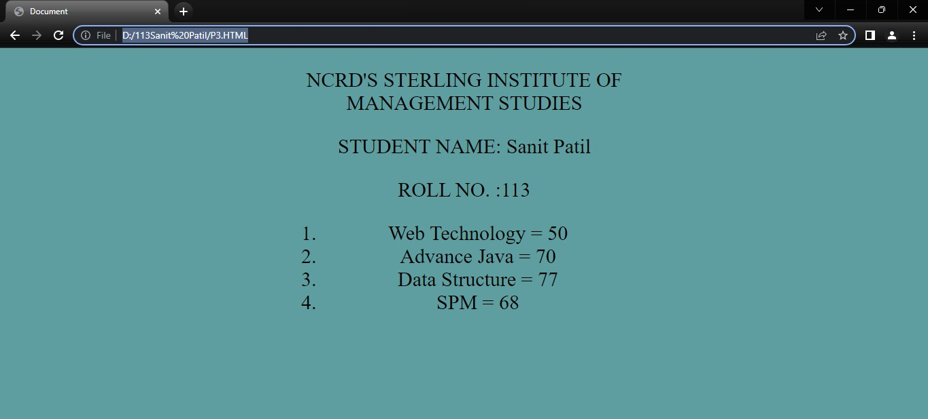

**Practical No. 33**

#### Create an Application in Angular JS to change the background color of a textbox as written in textbox

<!DOCTYPE html>

<html lang="en">

<head>

<script src="angular.min.js"></script>

<meta charset="UTF-8">

<meta http-equiv="X-UA-Compatible" content="IE=edge">

<meta name="viewport" content="width=device-width, initial-scale=1.0">

<title>Document</title>

</head>

<body>

<h1>To change the bakground color of the textbox</h1>

<div ng-app="" ng-init="color='green'"> color=<input style="background-color:{{color}}" ng-model="color">

</div>

</body>

</html>

#### Output:

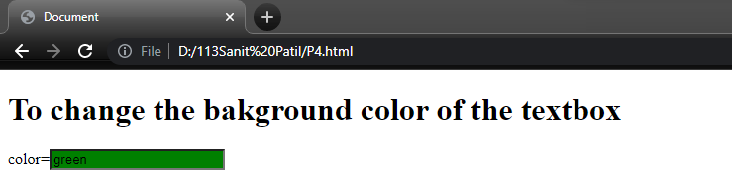

**Practical No. 34**

#### Create an Application to Calculate Simple Interest in Angular JS.

<!DOCTYPE html>

<html lang="en">

<head>

<script src="angular.min.js"></script>

<meta charset="UTF-8">

<meta http-equiv="X-UA-Compatible" content="IE=edge">

<meta name="viewport" content="width=device-width, initial-scale=1.0">

<title>Document</title>

</head>

<body>

<div ng-app="" ng-init="">

<label>enter amount</label><input type="number" ng- model="p"/><br>

<label>enter rate</label><input type="number" ng- model="r"/><br>

<label>enter time</label><input type="number" ng- model="t"/><br>

<p>Simple interest :- {{(p*r*t)/100}}</p>

</div>

</body>

</html>

#### Output:

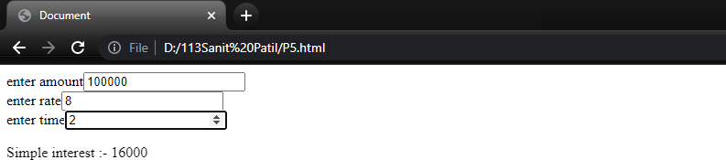

**Practical No. 35**

* **Create an Application to demonstrate Controller using Angular JS**

###### HTML Code

<!DOCTYPE html>

<html ng-app="MyMod">

<head>

<meta charset="UTF-8">

<meta http-equiv="X-UA-Compatible" content="IE=edge">

<meta name="viewport" content="width=device-width, initial- scale=1.0">

<script src="angular.min.js" ></script>

<script src="controller.js" ></script>

<title>Document</title>

</head>

<body>

<div ng-controller="MyControl" >{{message}}

</div>

</body>

</html>

###### JS Code

var MyApp=angular.module("MyMod",[]); MyApp.controller("MyControl",function($scope)

{

$scope.message="AngularJS";

});

#### Output:

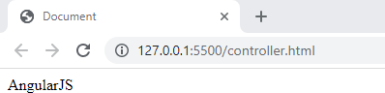

**Practical No. 36**

* **Create an application in Angular to display a checkbox as Click and 2 textboxes as Readonly and Able/Disabled. If the checkbox is checked then only the 1st textbox should be readonly and the second should be disabled.**

<!DOCTYPE html>

<html lang="en">

<head>

<meta charset="UTF-8">

<meta http-equiv="X-UA-Compatible" content="IE=edge">

<meta name="viewport" content="width=device-width, initial-scale=1.0">

<title>Document</title>

</head>

<body ng-app ng-init="checked=true"> Click Me: <input type="checkbox" ng-

model="checked"></br>

<div>

New: <input ng-if="checked" type="text">

</div>

<div>

Read-only: <input ng-readonly="checked" type="text" value="This is read only">

</div>

<div>

Disabled: <input ng-disabled="checked" type="text" value="this is disabled">

</div>

</body>

</html>

#### Output:

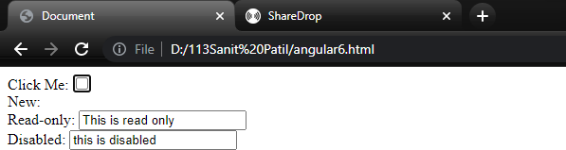

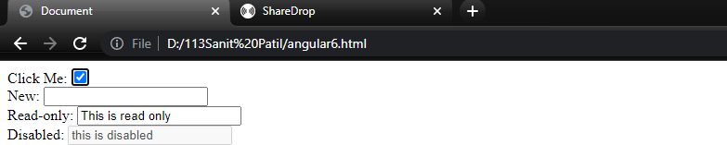

**Practical No. 37**

* **Create an Application in Angular JS to display list of Programming Language in a table format,provide the button for like and dislike and increment the value of like and dislike when the respective button are close**

#### .js File

var app=angular

.module("myModule",[])

.controller("myController", function ($scope){ var technologies=[

{name:"C#", likes:0,dislikes:0},

{name:"ASP.NET",like:0,dislikes:0},

{name:"SQL",likes:0,dislikes:0},

{name:"AngularJS",likes:0,dislikes:0}

];

$scope.technologies=technologies;

$scope.incrementLikes=function(technology){ technology.likes++;

};

$scope.incrementDislikes=function(technology){

technology.dislikes++

};

**.html File**

});

<!DOCTYPE html>

<html lang="en">

<head>

<meta charset="UTF-8">

<meta http-equiv="X-UA-Compatible" content="IE=edge">

<meta name="viewport" content="width=device-width, initial-scale=1.0">

<title>Document</title>

<script src="angular.min.js"></script>

<script src="fourth.js"></script>

<script src="fourth.css"></script>

</head>

<body ng-app="myModule">

<div ng-controller="myController">

<table>

<thead>

<tr>

<th>Name</th>

<th>Likes</th>

<th>Dislikes</th>

<th>Likes/Dislikes</th>

</tr>

</thead>

<tbody>

<tr ng-repeat="technology in

technologies">

<td>{{ technology.name}}</td>

<td style="text-align:center">{{

technology.likes}}</td>

<td style="text-align:center">{{ technology.dislikes}}</td>

<td>

<input type="button" ng- click="incrementLikes(technology)" value="Like"/>

<input type="button" ng- click="incrementDislikes(technology)" value="Dislike"/>

</td>

</tr>

</tbody>

</table>

</div>

</body>

</html>

**.css File**

table{

border-collapse: collapse; font-family:Arial;

}

td{

Border: 1px solid black; padding: 5px;

}

th{

border: 1px solid black; padding: 5px;

text-align: left;

}

#### Output:

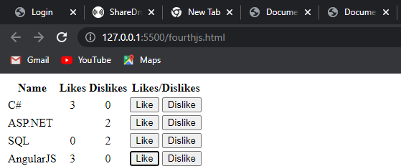

**Practical No. 38**

* **Create an application to change the background color of using ng-switch directive a division**

<!DOCTYPE html>

<html lang="en">

<head>

<meta charset="UTF-8">

<meta http-equiv="X-UA-Compatible" content="IE=edge">

<meta name="viewport" content="width=device-width, initial-scale=1.0">

<title>Document</title>

<script src="angular.min.js"></script>

</head>

<body ng-app="">

<div>

<form>Select Color :

<select ng-model="myVar">

<option value="pink">Pink</option>

<option value="ablu">Sky Blue</option>

<option value="lav">Lavender</option>

</select>

</form>

</div>

<div ng-switch="myVar">

<div ng-switch-when="ablu" style="background- color: lightblue;">

<h1>Sky Blue</h1>

<p>Sky Blue Color.</p>

</div>

</div>

<div ng-switch="myVar">

<div ng-switch-when="pink" style="background- color: pink;">

<h1>Pink</h1>

<p>Pink Color.</p>

</div>

</div>

<div ng-switch="myVar">

<div ng-switch-when="lav" style="background- color: rgb(226, 184, 253);">

<h1>Lavender</h1>

<p>Lavender Color</p>

</div>

</div>

<p>The ng-switch directive hides and show HTML selections depending on the value of the dropdown list.</p>

</body>

</html>

#### Output:

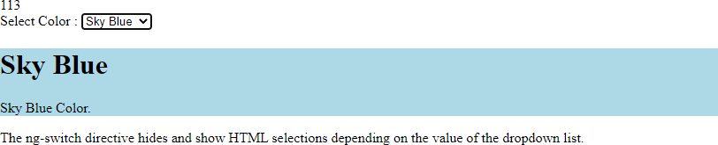

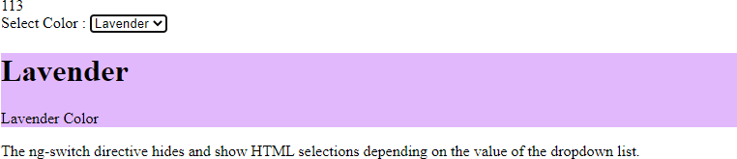

**Practical No. 39**

* **Create an Application to Display Employee details in a table using filters**

#### .js

var app = angular .module("myModule", []).controller("myController", function ($scope){

var employees = [

{

name:"Luffy",dateOfBirth:new

Date("November 23,

1980"),gender:"Male",salary:55000000000000.999

},

{

name:"Sana",dateOfBirth:new Date("May 05, 1970"),gender:"Female",salary: 68000

},

{

name: "Patsy", dateOfBirth: new Date("August 15, 1974"),gender: "Female", salary: 57000

},

{

name: "Chopper", dateOfBirth: new Date("February 30, 1947"),gender: "Male", salary: 500

},

];

$scope.employees = employees;

$scope.rowCount = 3;

})

#### .html

<!DOCTYPE html>

<html lang="en">

<head>

<meta charset="UTF-8">

<meta http-equiv="X-UA-Compatible" content="IE=edge">

<meta name="viewport" content="width=device-width, initial- scale=1.0">

<title>Document</title>

<script src="angular.min.js"></script>

<script src="filters.js"></script>

<style>

body{

font-family: Arial, Helvetica, sans-serif;

}

table{

border-collapse: collapse;

}

td{

border: 1px solid black; padding: 5px;

}

th{

border: 1px solid black; padding:5px;

text-align: left;

}

</style>

</head>

<body ng-app="myModule">

<div ng-controller="myController">

Rows to display:<input type="number" step="1" min="0" ng- model="rowCount" max="5"/>

<br/>

<table>

<thead>

<tr>

<th>Name</th>

<th>Date of Birth</th>

<th>Gender</th>

<th>Salary (number filter)</th>

<th>Salary (currency filter)</th>

</tr>

</thead>

<tbody>

<tr ng-repeat="employee in employees | limitTo:rowCount">

<td>{{employee.name | uppercase}}</td>

<td>{{employee.dateOfBirth | date:"dd/MM/yyyy"}}</td>

<td>{{employee.gender | lowercase}}</td>

<td>{{employee.salary | number:2}}</td>

<td>{{employee.salary | currency}}</td>

</tr>

</tbody>

</table>

</div>

</body>

</html>

# .css

Body{

font-family:Arial;

}

table{

border-collapse: collapse;

}

td{

border:1px solid black; padding:5px;

}

th{

border:1px solid black; padding:5px;

text-align:left;

}

### Output:

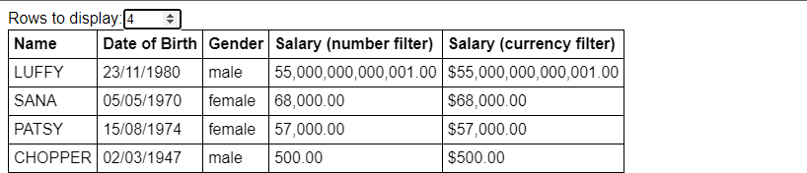

**Practical No. 40**

###### Create an Application in Angular JS to demonstrate Mouse events ng-mouse enter and ng-mouseleave.

<!DOCTYPE html>

<html>

<head>

<script src="angular.min.js"></script>

<style>

.redDiv {

width: 500px; height: 50px;

background-color: red; padding:2px 2px 2px 2px;

}

.yellowDiv {

width: 500px; height: 50px;

background-color: rgb(1, 255, 56); padding:2px 2px 2px 2px;

}

</style>

</head>

<body ng-app>

<div ng-class="{redDiv: enter, yellowDiv: leave}" ng-mouseenter="enter=true;leave=false;" ng- mouseleave="leave=true;enter=false">

Mouse <span ng-show="enter">Enter</span> <span ng-show="leave">Leave</span>

</div>

</body>

</html>

### Output:

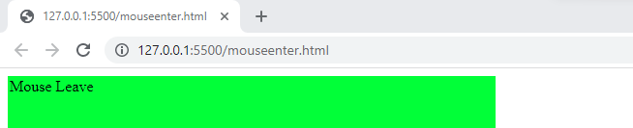

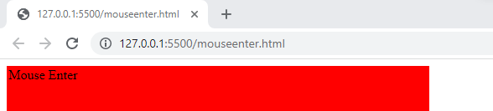

**Practical No. 41**

* **Create an Application SPA.**

###### Contact.html

<div class = "jumbotron text-center">

<h1>Contact Page</h1>

<p>

You can Contact us on 5412356890

</p>

<p>{{message}}</p>

</div>

###### about.html

<div class = "jumbotron text-center">

<h1>About Page</h1>

<img src = "download.png" alt="js">

<p>{{message}}</p>

</div>

###### home.html

<div class = "jumbotron text-center">

<h1>home Page</h1>

<h3>We can build Single Page Application (SPA) with AngularJS. It is a web app that loads a single HTML page and dynamically

updates that page as the user interacts with the web app. AngularJS supports SPA using routing module ngRoute.

This routing module acts based on the url. When a user requests a specific url,

the routing engine captures that url and renders the view based

on the

defined routing rules.</h3>

<p>{{message}}</p>

</div>

###### spa.html

<!DOCTYPE html>

<html ng-app="myApp">

<head>

<link rel="stylesheet" href= "//netdna.bootstrapcdn.com/bootstrap/3.0.0/css/bootstrap.min.css" />

<link rel="stylesheet" href= "//netdna.bootstrapcdn.com/font- awesome/4.0.0/css/font-awesome.css" />

<script src= "https://ajax.googleapis.com/ajax/libs/angularjs/1.2.25/angular.min.js "></script>

<script src="//ajax.googleapis.com/ajax/libs/angularjs/1.2.25/angular- route.js"></script>

<script src="angular.min.js"></script>

<script src="spa.js"></script>

</head>

<body ng-controller="mainController">

<header>

<nav class="navbar navbar-default">

<div class="container">

<div class="navbar-header">

<a class="navbar-brand" href="/">Angular Routing

Example</a>

</div>

<ul class="nav navbar-nav navbar-right">

<li><a href="#"><i class="fa fa-home"></i>

Home</a></li>

<li><a href="#about"><i class="fa fa-shield"></i>

About</a></li>

<li><a href="#contact"><i class="fa fa- comment"></i> Contact</a></li>

</ul>

</div>

</nav>

</header>

<div id="main">

<div ng-view></div>

</div>

</body>

</html>

###### spa.js

var myApp = angular.module('myApp', ['ngRoute']);

// configure our routes myApp.config(function($routeProvider) {

$routeProvider

// route for the home page

.when('/', {

templateUrl : 'home.html', controller : 'mainController'

})

// route for the about page

.when('/about', {

templateUrl : 'about.html', controller : 'aboutController'

})

.when('/contact', {

templateUrl : 'contact.html', controller : 'contactController'

});

});

// create the controller and inject Angular's $scope myApp.controller('mainController', function($scope) {

// create a message to display in our view

$scope.message = 'Everyone come and see how good I look!';

});

myApp.controller('aboutController', function($scope)

{ $scope.message = 'Look! I am an about page.';

});

myApp.controller('contactController', function($scope) {

$scope.message = 'Contact us! This is just a demo.';

});

### Output:

